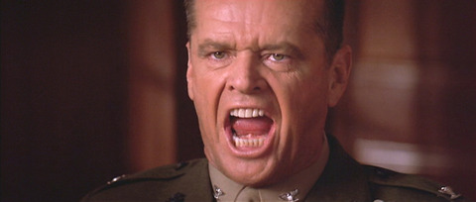

Son we live in a world that has wrestling mats, and those wrestling mats have to be guarded by men with whistles. Who’s gonna do it? You, Wrestling Fan? I have a greater responsibility than you could possibly fathom. You weep for the wrestlers, and you curse the Referee. You have that luxury. You have the luxury of not knowing what I know. That wrestler’s disqualification, while tragic, probably prevented injuries. And my existence, while grotesque and incomprehensible to you serves a purpose which includes preventing injuries. You don’t want the truth because deep down in places you don’t talk about at parties, you WANT me on that mat, you NEED me on that mat. We use words like stalling, technical violation, and illegal. We use these words as the backbone of a life spent officiating. You use them as a punch line. I have neither the time nor the inclination to explain myself to a man who rises and sleeps under the blanket of sportsmanship that I provide, and then questions the manner in which I provide it! I would rather you just said thank you, and go on your way. Otherwise, I suggest you pick up a whistle, and get your striped shirt. Either way, I don’t give a DAMN what you think you are entitled to!

