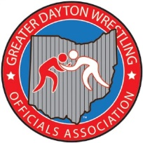GDWOA WEEKLY MINUTES
Date1/3/22
Location: CENTERVILLE HIGH SCHOOL

Meeting began at 7:00 with president Chaz Deshayes calling the meeting to order.
Present for meeting were 22 officials

Secretaries Report – UPGRADE TEST from class 2 to 1 Please let me know if you are going to upgrade. We need all to become class 1. Also a reminder that next weeks meeting will not be Monday but will be on Tuesday the 11th at Stebbins.

Treasurers Report – Balance is treasure is $12,710.67

New Business: No new business.

Presentation – Presentation was given by the board as group discussions prevailed on different topics. You make the call videos and great discussion was had. Steve L. recapped the GMVWA tourney. We needed to be louder and more clear in our calls and as always instructions on 2 man officiating.

Announcement: Tony S. announced that he emailed the state regarding our tune up meeting . He requested it to be counted as a regular credited meeting. He got the approval from OHSAA.

The meeting was adjourned at 8:25
Next meeting is at Stebbins High School. Jan 11th with Gerry G. and Kendall K. presenting Assistant officiating and Coaches conflict.

Respectfully submitted.
Tony Stapleton - Secretary

